MySQL Practice


1. Running the program using the MySQL 8.0 Command Line Client
1.1 Enter the command to display all databases.
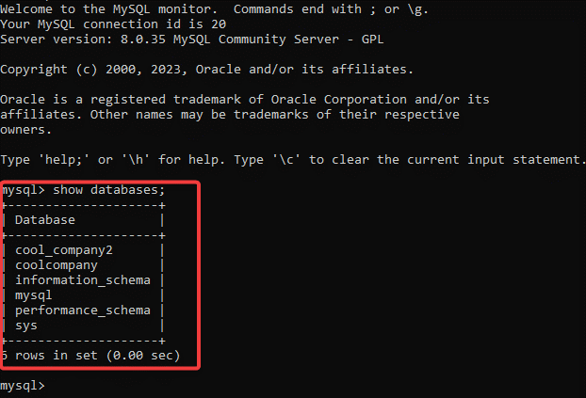
1.2 Select the database named "sys".
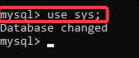
1.3 Show all tables in the database "sys".
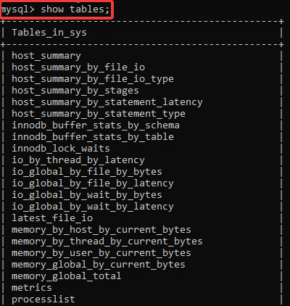
1.4 Show all data in the "host-summary" table
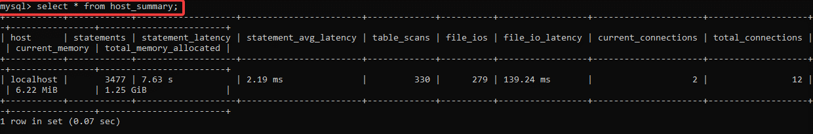
1.5 Exit the command line.
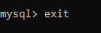
2. Create a database in two ways
2.1 Create a database that will support the Ukrainian Cyrillic alphabet using commands.
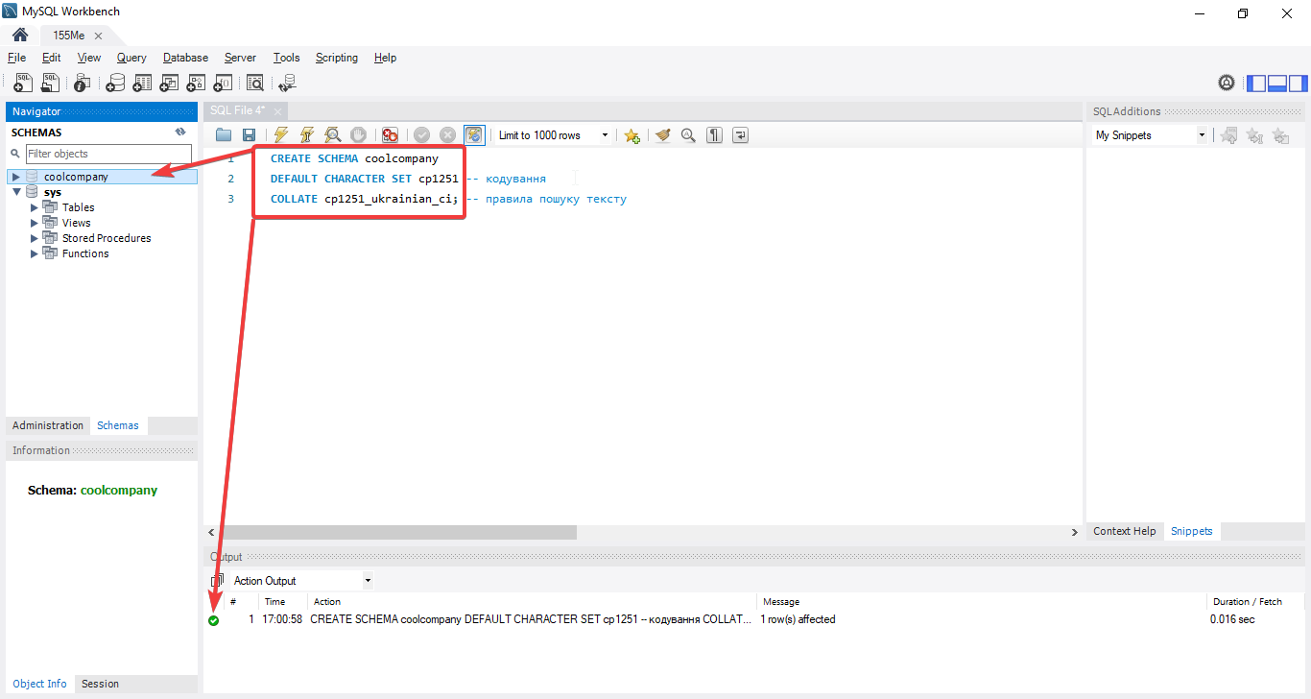

2.2 Create a database that will support the Ukrainian Cyrillic alphabet using the MySQL Workbench functionality.
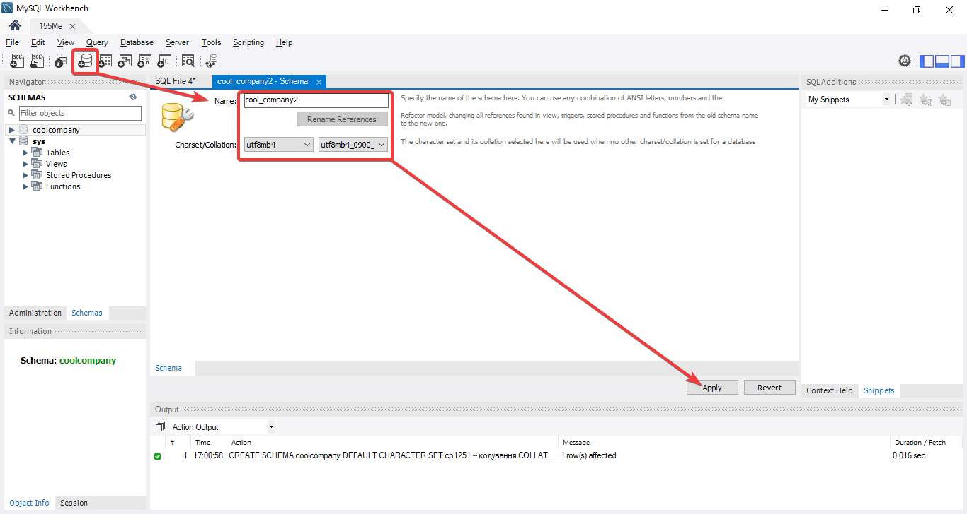

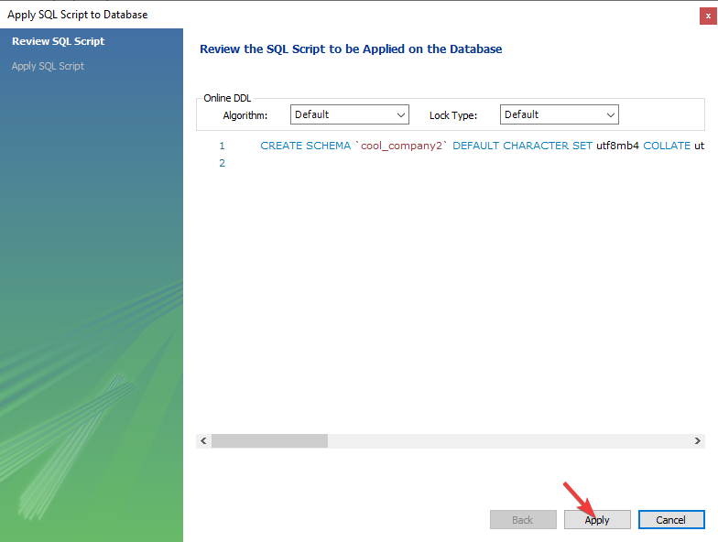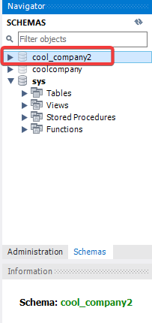

3. How to create a table in the Database (and what is the Primary Key)
3.1 Creating the "student" table using the commands.
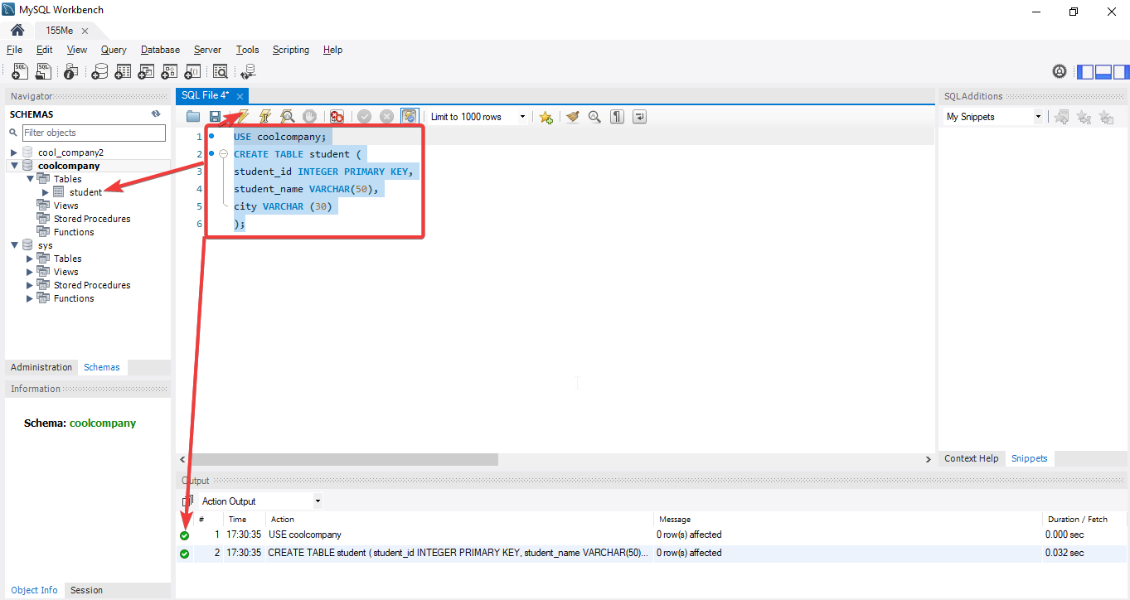
3.2 Display the table.
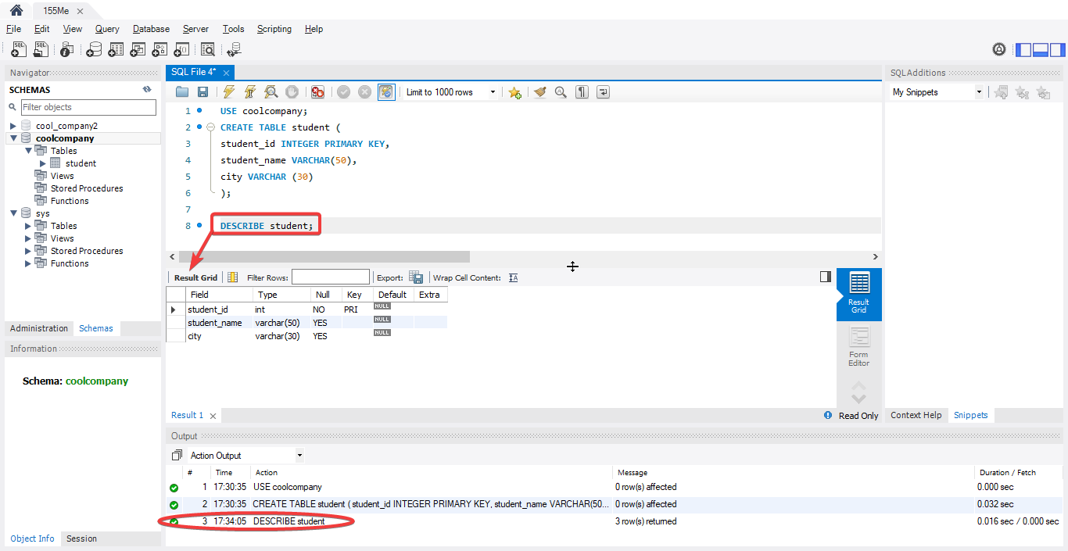
3.3 Create a table named "video" using the graphical shell of the MySQL Workbench program.
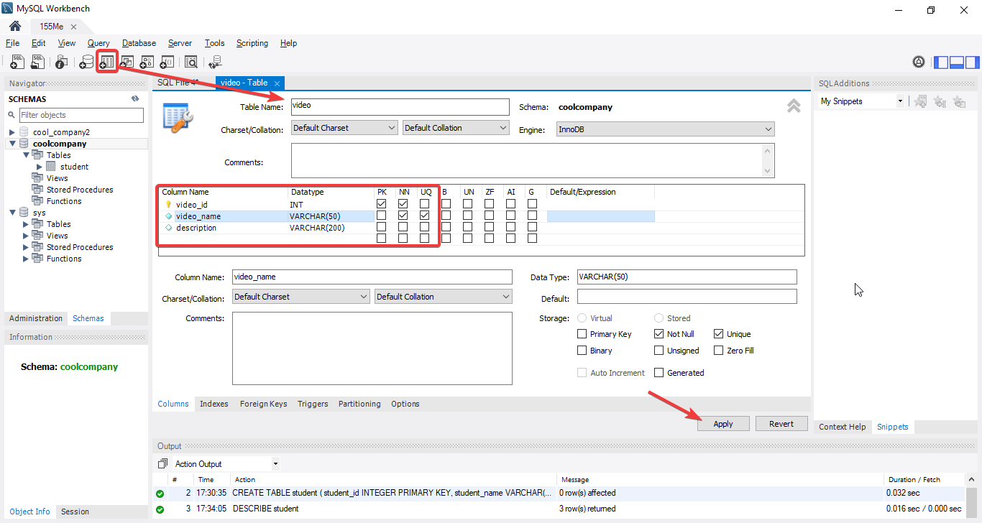

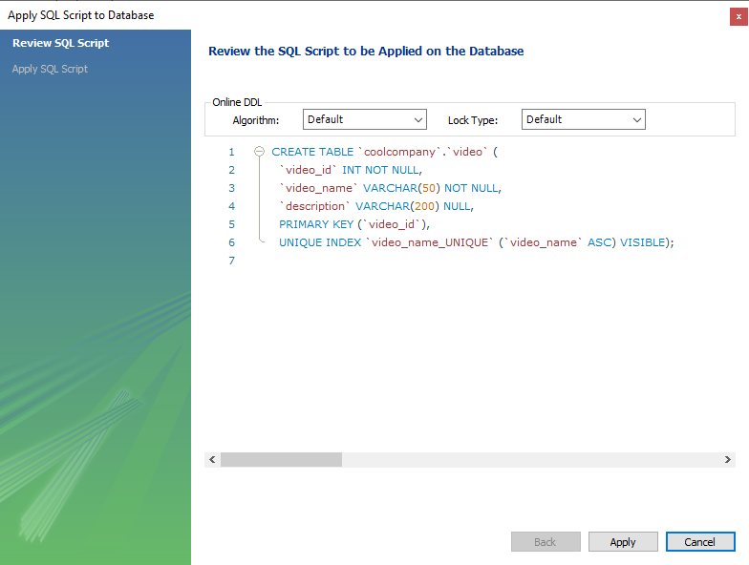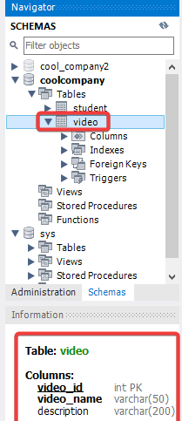
4. How to edit tables in a SQL database

4.1 Add a column with emails to the student table.
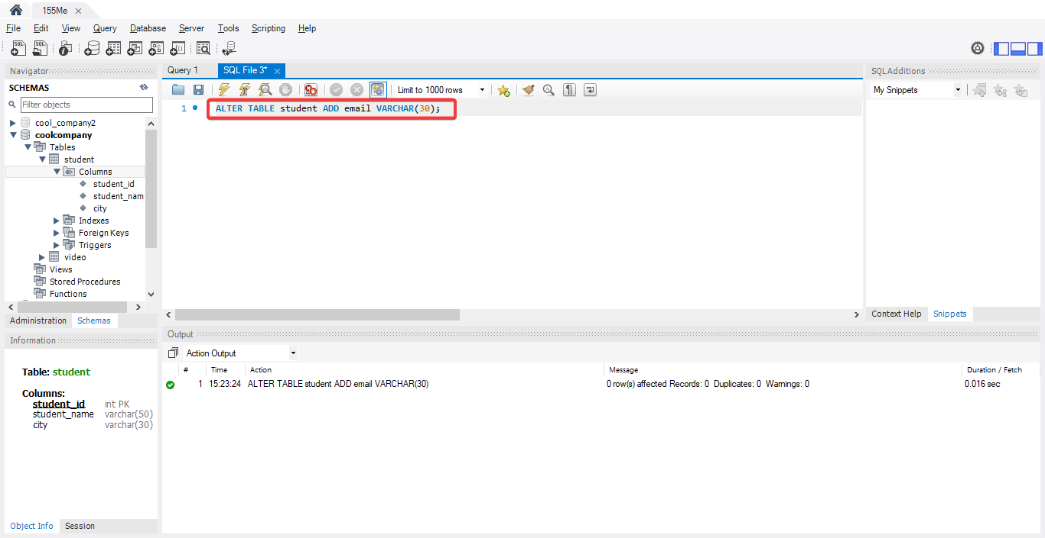
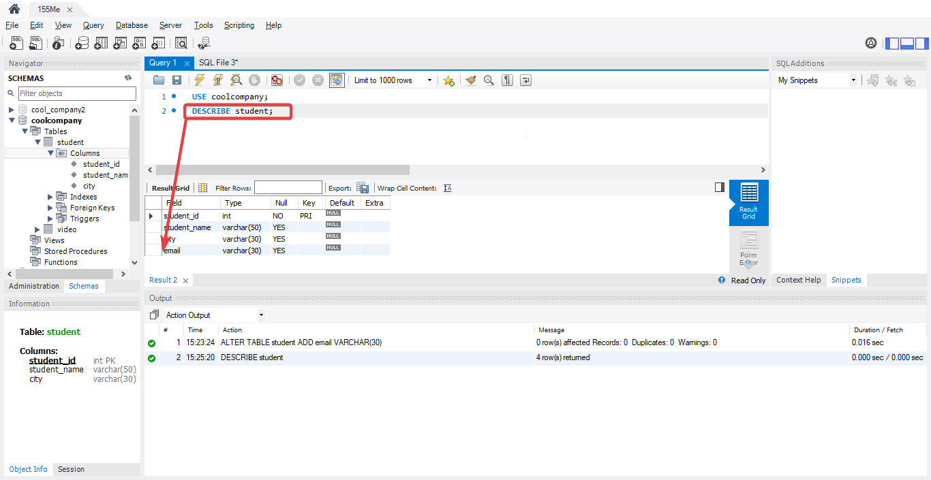
4.2 Delete the email column from the Student table.
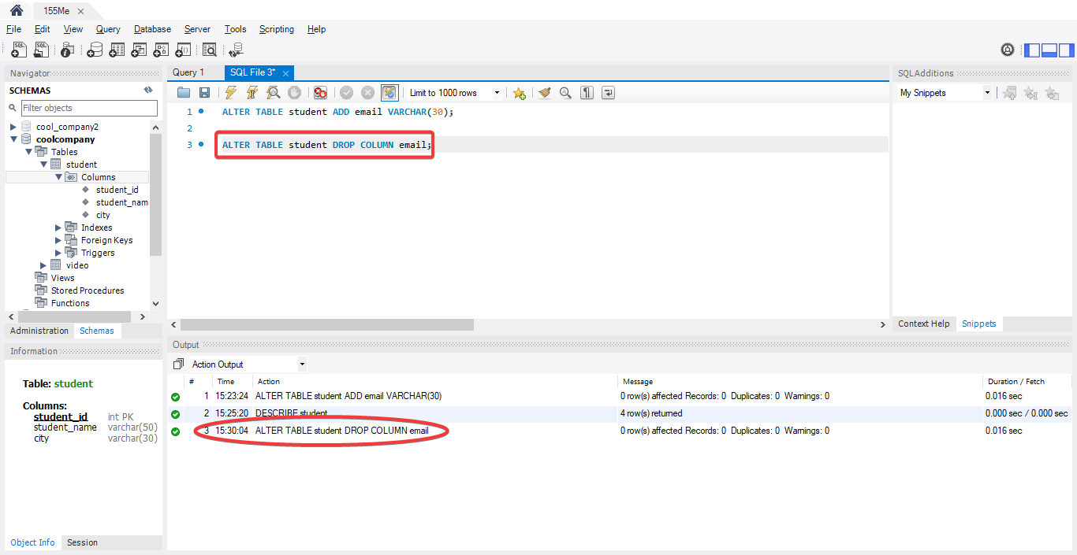
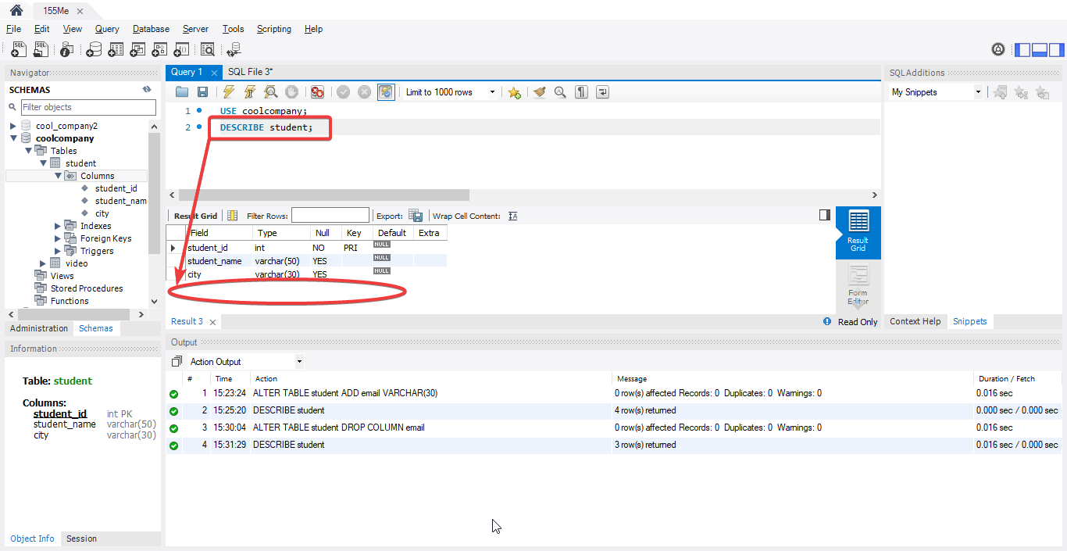
* Attempting to enter more than 30 characters in an email column.
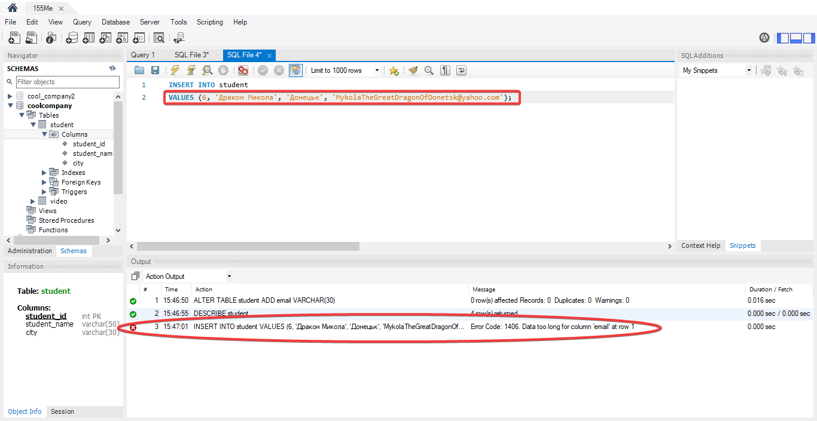
4.3 Change the size of characters that can be contained in the email column.
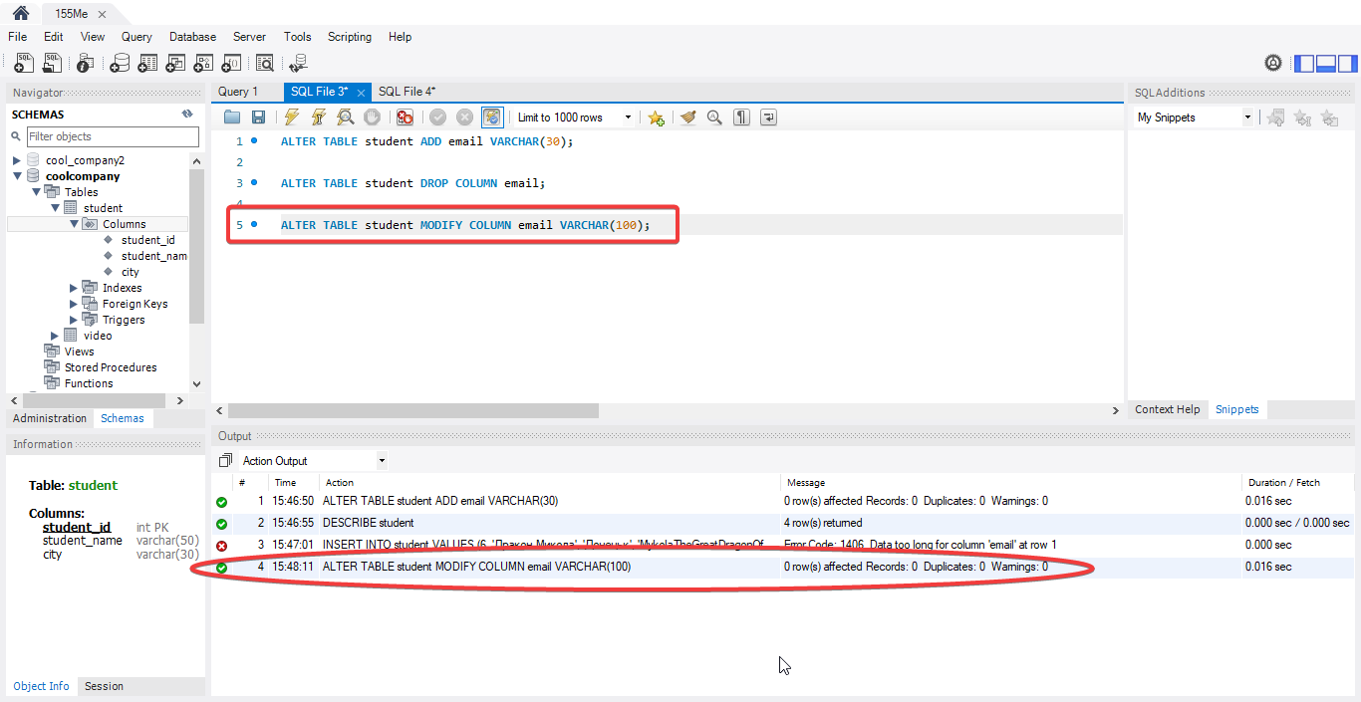
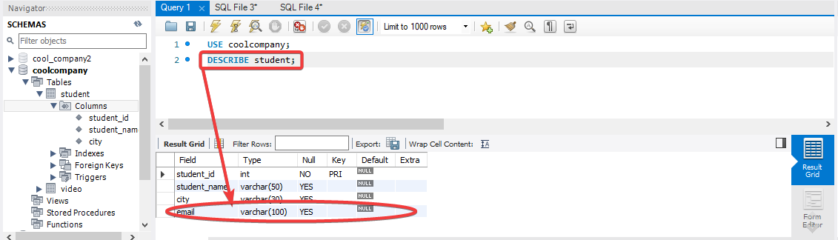
** Attempting to enter more than 30 characters in an email column after expanding the column to 100 characters.
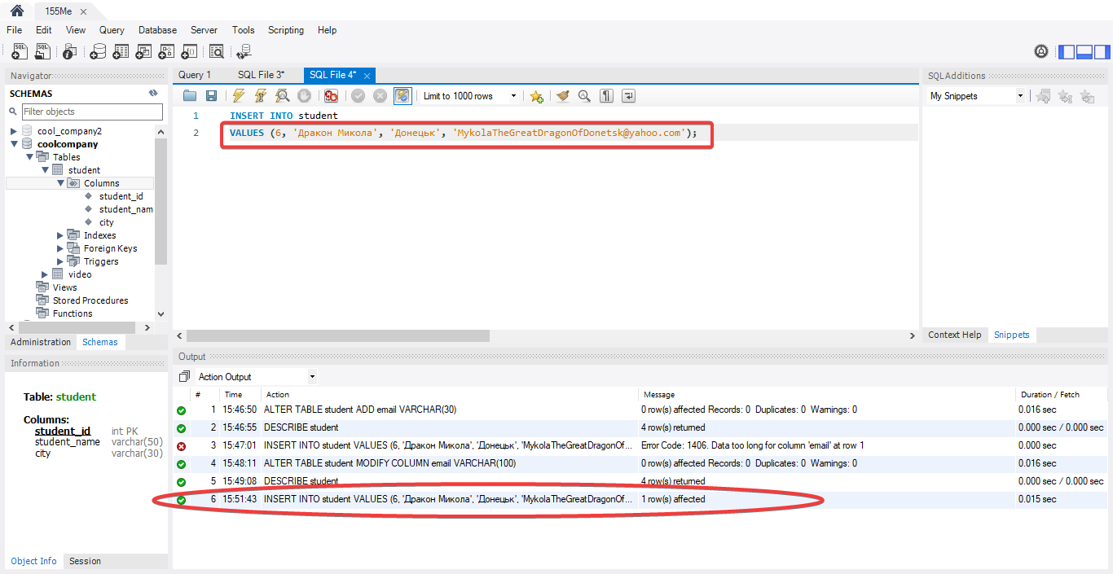
4.4 Edit a table using MySQL graphical tools
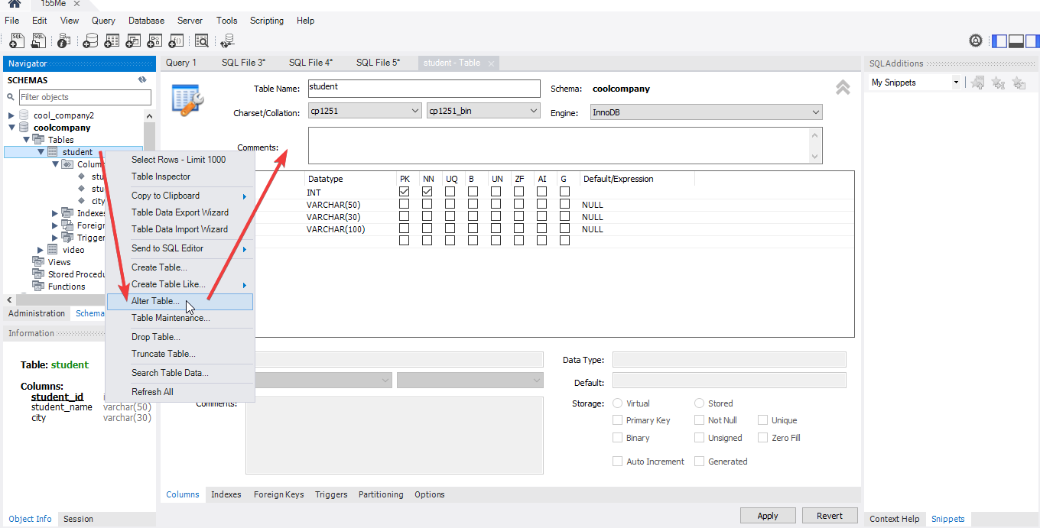
4.5 Delete the column you just added
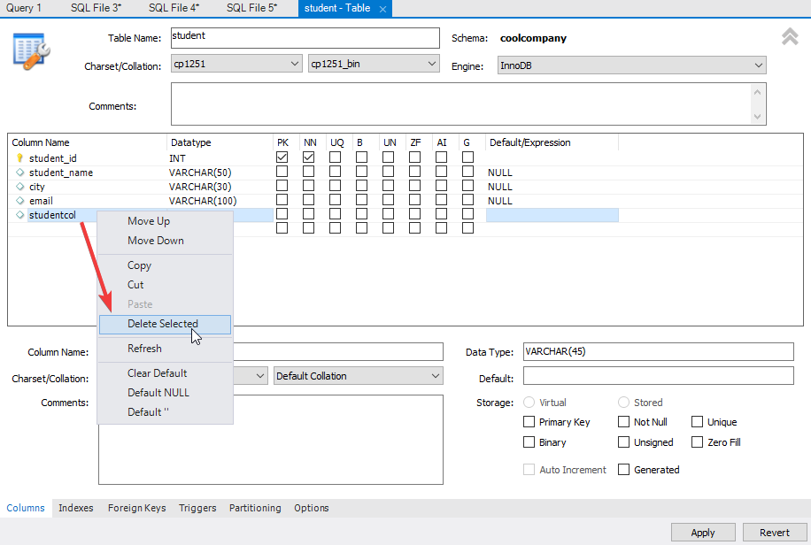
4.6 Change the size of characters that can be contained in the email column from 100 to 200.
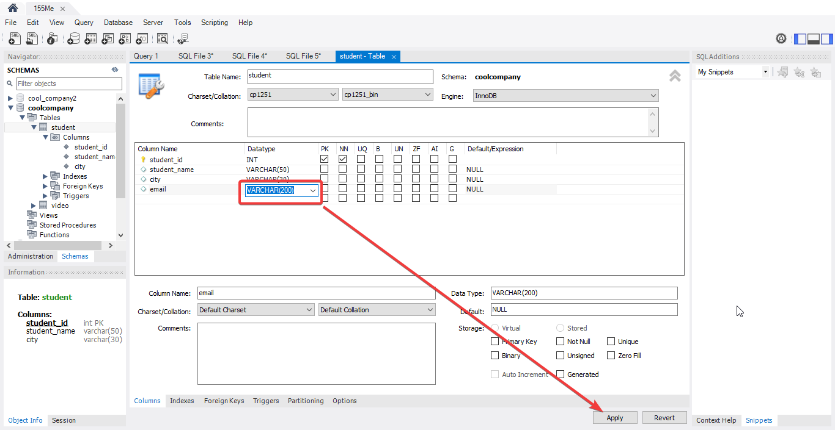
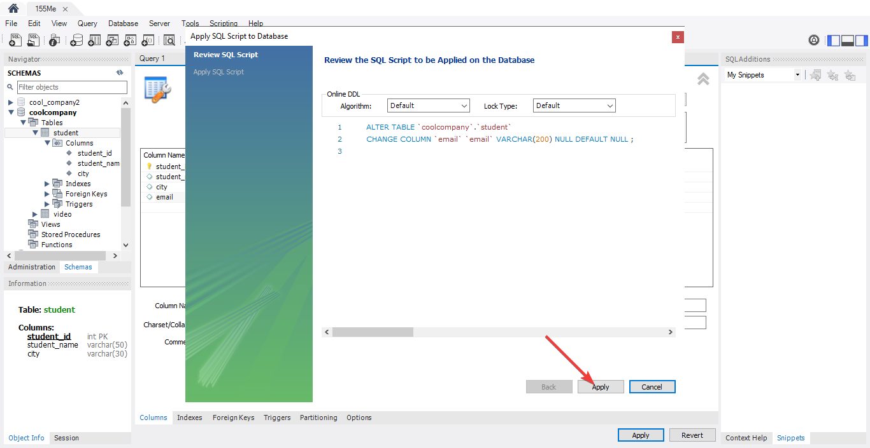
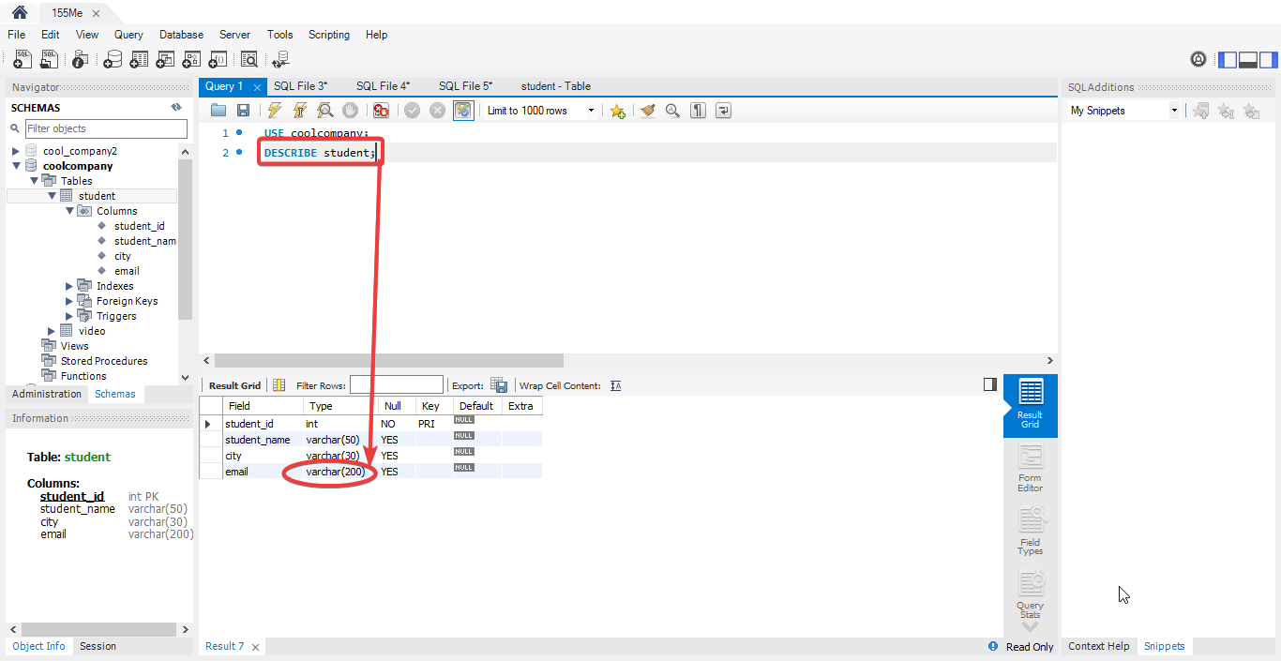
5. Delete a table and database

5.1 Delete the student table from the database.
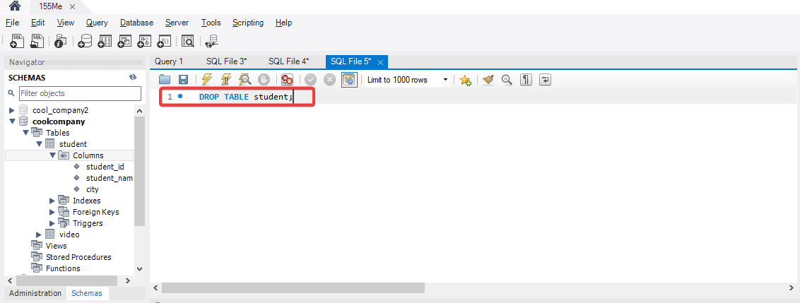
5.2 Delete coolcompany database.
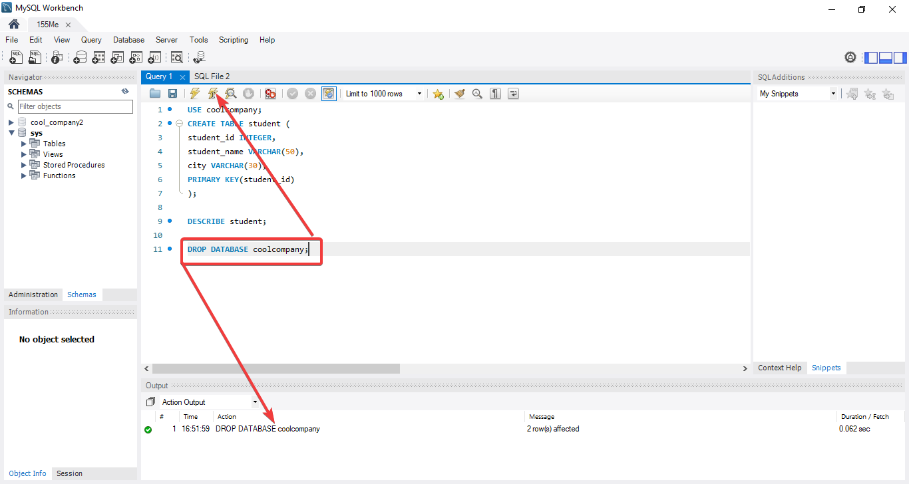
6. Working with data types
  - Create a table without specifying a data type.
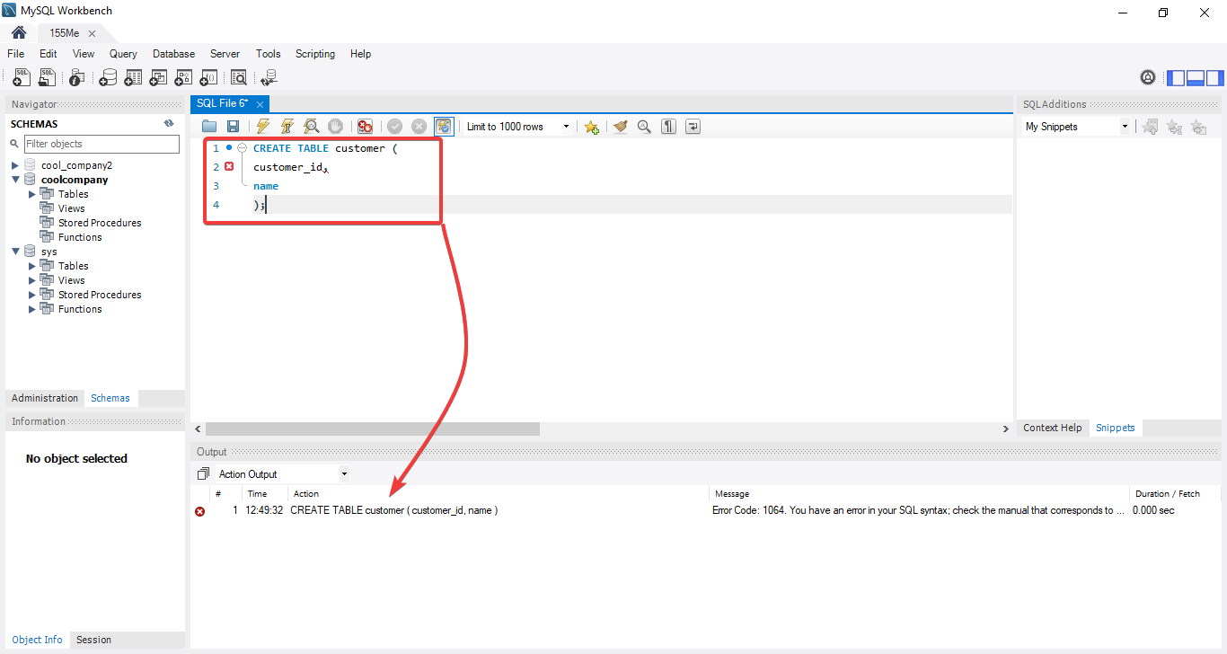
As expected, the system generates an error, because you cannot create a column without specifying the data type of each of them.
6.2 Specify the data types of each column and create a table.
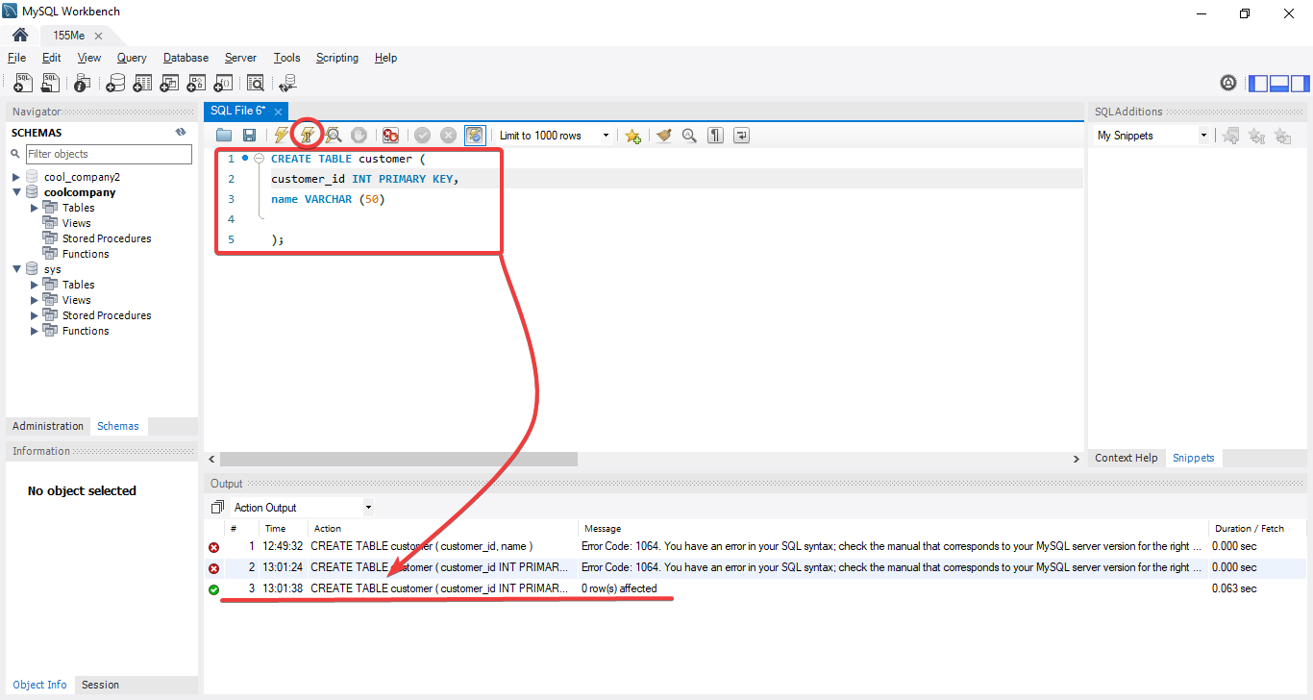
The table was created successfully without errors.
6.3 Add data to the table that does not fit its type.
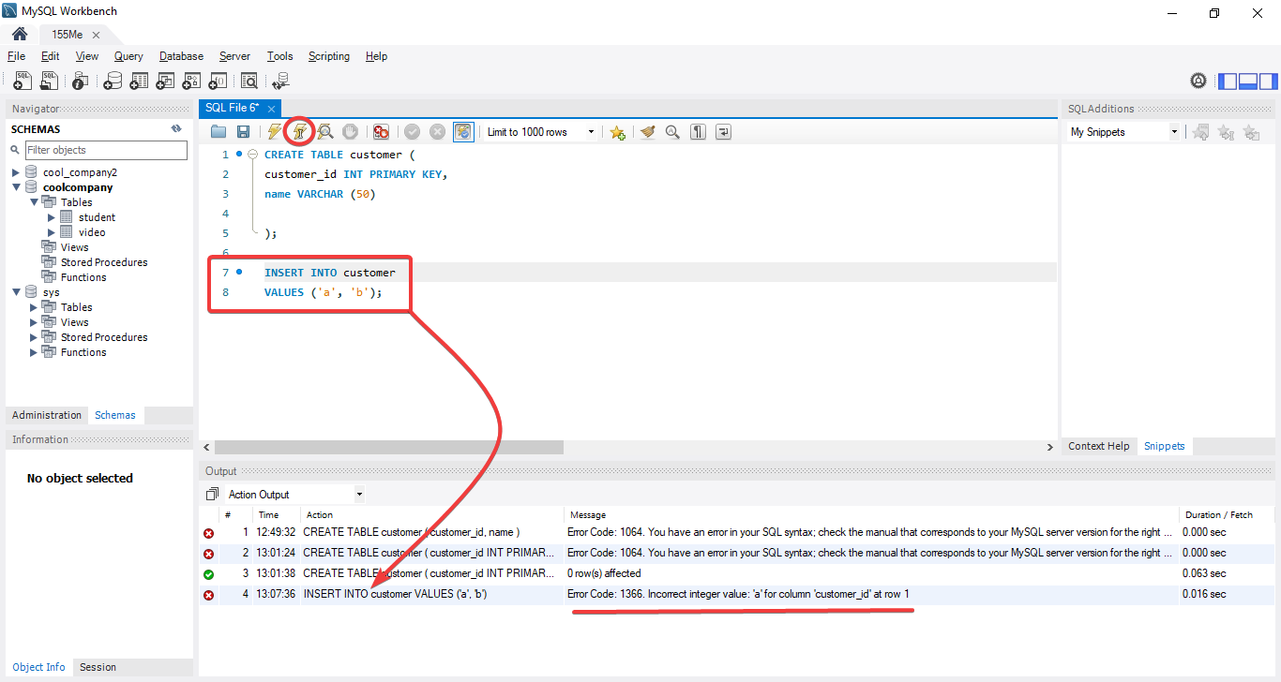
We get the expected error. After all, you can't insert a text value into a column with an ID (INT type).
6.4 Fill in the table with the appropriate data types. To speed up this process, we use the visual components of MySQL Workbench.
